**DESKTOP :**

**Overall –**

* Can we get a sticky nav here for the sections? If someone is injured, this might limit there use of hand movements. Easy navigation should be top priority for a page like this
* Utilize full width more – the different colors contrasting breaks up your page in a bad way, looks incomplete (even though it is right now)
* Try to stagger your colors more, light grey background going to dark grey should be a no-no. Same for white going to light grey

**Top Form section –**

~~I don’t think we need the bars leading to the sign up.~~

~~Some spacing and structure changes can make it look much simpler:~~

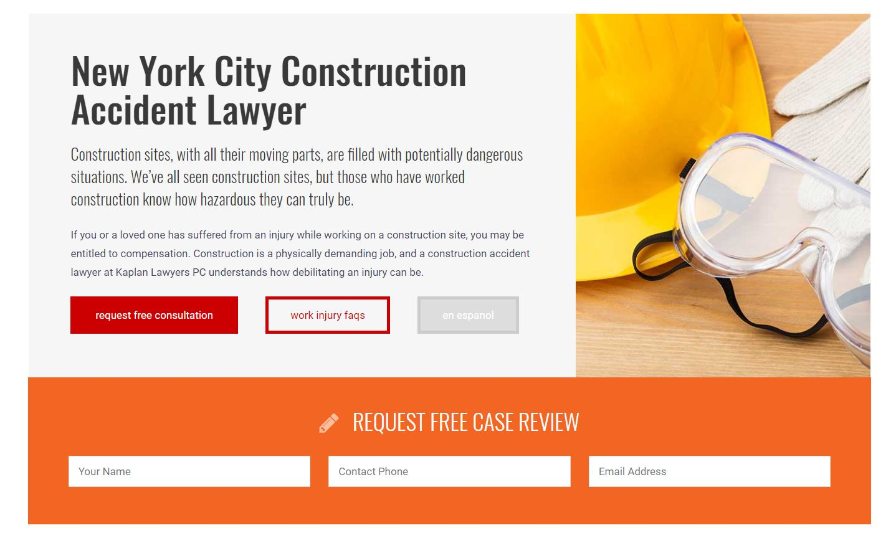

I think with the spacing, and the way it’s laid out, this could be good as a secondary section, after a hero of some sort. This can also be full-width.

**Construction Injury Topic Index -**

~~Good opportunity to add some typography here – just changing the order of lines starts to look better:~~

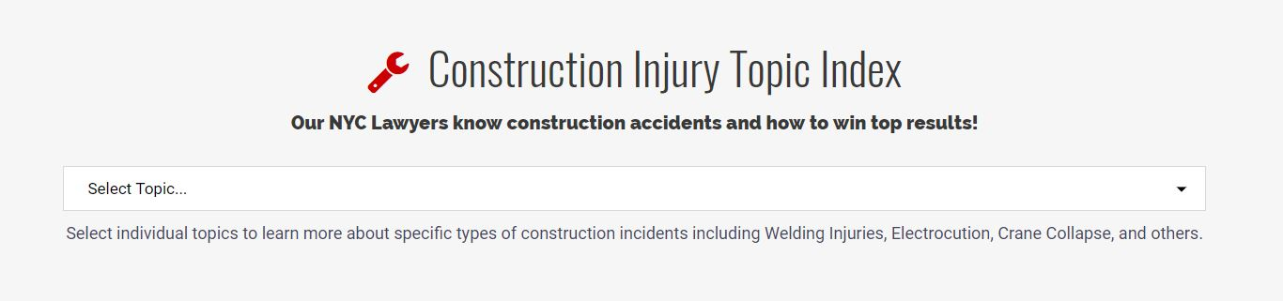

Also, it’s possible to actually change the drop-down icon, maybe an arrow or spot color change.

This could be an area for a background image with an overlay, to change things up a bit.

**Am I Qualified for Compensation in New York?**

Links in list – this can be another area to incorporate a different icon on hover. Maybe an arrow? SVG and CSS animations would look good.

Float the bottom button to the right.

**Construction Companies Owe Workers a Safe Environment**

~~Break up text for an easier read – looks better, as well.~~

~~Use consistent colors, if the strikes and highlights are red, the button should be. I see what you’re doing with the color changes, but I think it looks better here to keep colors consistent.~~

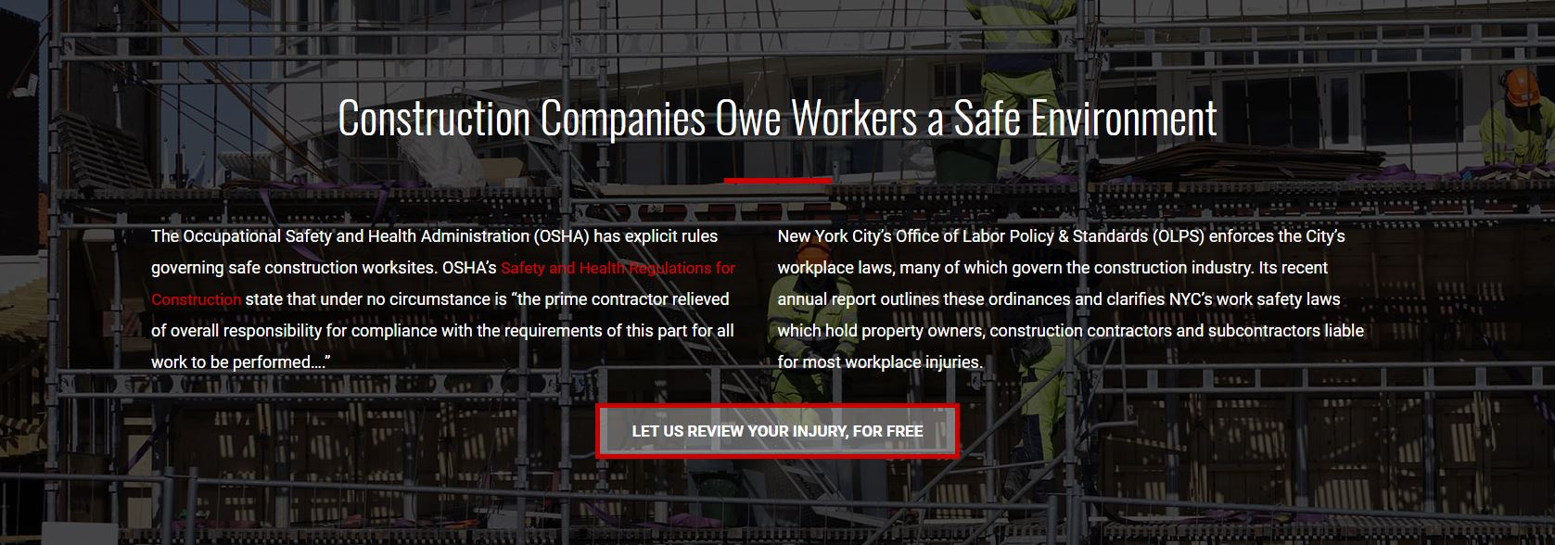

**What to Expect in the Claims Process / The Appeals Process –**

~~Keep Icons consistent – if you’re using standalone, keep using standalone (not knockout)~~

~~Instead of the grey BG, use white. Supplement change with a border, to signify category change.~~

Keep buttons consistent. Adjust width of categories for visual differentiation

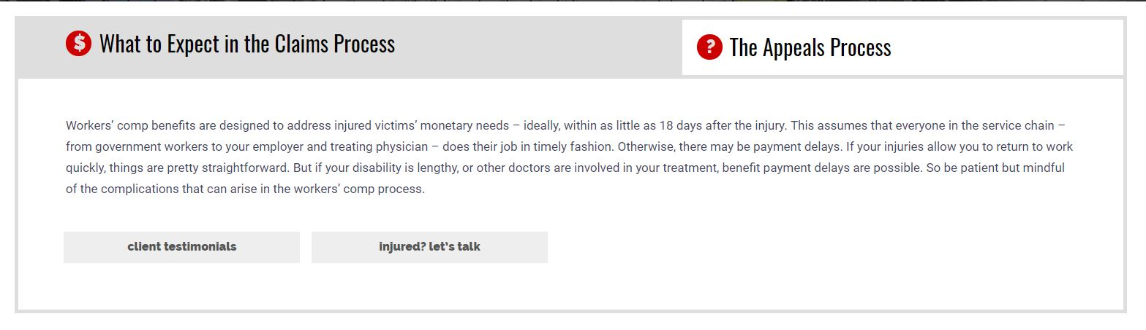

**10 Alarming Construction Work Injury Stats –**

This should be a section by itself. Can be staggered left to right, using a 2 column grid. Optional, since it seems to be making sense with the column to its right.

If you’re using the infographic images, best to fit them to the space you’re putting them in. Maybe make this a consistent option for use later. With some simple JS and CSS, you wont need thumbnails.

**Have you been involved in any of the following types of accident?**

~~Iconography can be of use here. Creating a visual hierarchy is important here because of the amount of content. Shown here, easy to change out the Css. ::after tag can be further manipulated.~~

~~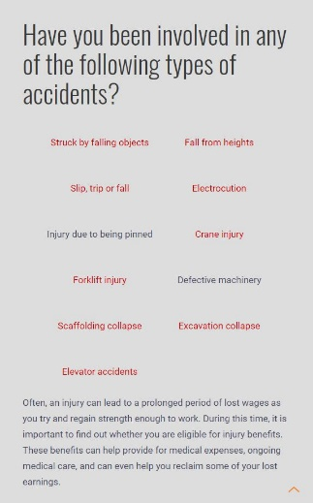~~

~~Two column grid would be useful, to create a distinction between calls to action and plain text.~~

**Need Help? –**

This should be a call to action, maybe like the **Construction Companies Owe Workers a Safe Environment** section.

Always differentiate phone numbers and location against normal <p> tags. Even bolding helps.

***MOBILE :***

**Overall –**

* Center button text
* Use margins – everything looks like it is pressing against the side of the screen
* To reduce scrolling, would be a good idea to collapse the articles somehow. They’re bulky, and not entirely necessary.
* You don’t need ‘Construction Injury Topic Index’ more than once. Keep it at the top for easy access on both mobile and desktop.
* In ‘Construction Injury Topic Index’ have an anchored link leading to the contact form.
* Don’t move between centered and left aligned headers, pick one. The left aligned looks best.
* For headers with icons – is it possible to float them to the back, behind the text? They’re taking a lot of space, and will kill the layout on smaller mobile usage.
* Users might not care about infographics here, eliminate for mobile?

**FAQs: Construction Accidents & Injuries –**

All items should be collapsed to reduce scrolling

**Construction Companies Owe Workers a Safe Environment –**

Left align any body text

**What to Expect in the Claims Process / The Appeals Process**

Tabs should at the least be same text size as body here. Need to make visual differentiation from tabs – like above mentioned for desktop.

**10 Alarming Construction Work Injury Stats –**

Add a styling to the numbers, give some sort of visual hierarchy.

**New York Construction Accident Articles –**

This needs to be a carousel

**Contact –**

User will get stuck for a moment scrolling through this – there tap will fire in the scroll box.

* + Could remove scrollbox completely on mobile.
  + Another option is to have a collapsed version with a header, if they want to contact a specific county they can then select from a dropdown.
  + Full width button, not partial